1. **Define HCI. Why do we need to study HCI?**

**Answer:**

**Definition:** Human-Computer Interaction (HCI) is a multidisciplinary field of study focusing on the design of computer technology and, in particular, the interaction between humans (the users) and computers. While initially concerned with computers, HCI has since expanded to cover almost all forms of information technology design.

**Why:** **Human**–**computer interaction** researches the design and use of **computer** technology, focused on the interfaces between people and **computers.**

Because it is the foundation of the digital world. Everything we build must ultimately interact with a human at some point. As machines get more complex, the nature of that interaction must be ever more understood, otherwise we risk losing efficiency and capability because of the human-computer *bottleneck.*

Furthermore, if you are a business man who doesn’t understand HCI, and your product is at least partially built upon people interacting with a computer, then you are at a severe competitive disadvantage. *Every* company today is partially digital because basically every company has a website. At the very least, your website needs to be good. The better you understand the point of user interaction, the more pleasurable you can make it, the more engaging you can make it, and the more profitable you can make it.

1. **What are the skill needed to produce an effective design?**

**Answer:**

HCI is undoubtedly a multi-disciplinary subject. The ideal designer of an interactive system would have expertise in a range of topics:

* **Psychology and cognitive science** - to give his knowledge of the user’s perceptual, cognitive and problem-solving skills.
* **Ergonomics** - for the user’s physical capabilities.
* **Sociology** - to help her understand the wider context of the interaction.
* Computer science and engineering – to be able to build the necessary technology.
* **Business** - to be able to market it.
* **Graphic design** - to produce an effective interface presentation;.
* **Technical writing** - to produce the manuals.

1. **Which components of computer are concern of HCI?**

**Answer:** Systems analysis has traditionally concerned itself with the influence of technology in the workplace, and fitting the technology to the requirements and constraints of the job.

HCI involves the design, implementation and evaluation of interactive systems in the context of the user’s task and work.

* People
* Computers and
* Tasks that are performed
* usability

The system must support the user’s task.

If the system forces the user to adopt an unacceptable mode of work then it is not usable.

1. **What do you mean by the myth “3V” in HCI?**

**Answer:** There are three ‘use’ words that must all be true for a product to be successful; it must be:

* **useful** – accomplish what is required: play music, cook dinner, format a document;
* **usable** – do it easily and naturally, without danger of error, etc.;
* **Used** – make people want to use it, be attractive, engaging, fun, etc.

1. **What do you mean by the User, Computer and Interaction?**

**User:**

By *user we may mean*

* *an individual* user,
* a group of users working together, or
* a sequence of users

In an organization, each dealing with some part of the task or process.

The user is whoever is trying to get the job done using the technology.

**Computer:**

By computer we mean

* any technology ranging from the general desktop computer to a large-scale computer system,
* a process control system or
* An embedded system.

The system may include non-computerized parts, including other people.

**Interaction:**

By *interaction we mean any communication between* a user and computer, be it direct or indirect.

Direct interaction involves a dialog with feedback and control throughout performance of the task.

Indirect interaction may involve batch processing or intelligent sensors controlling the environment.

The important thing is that the user is interacting with the computer in order to accomplish something.

1. **Clearly explain the “Laws of size Constancy”.**

* **Answer:** Given that the visual angle of an object is reduced as it gets further away, we might expect that we would perceive the object as smaller.
* In fact, our perception of an object’s size remains constant even if its visual angle changes.
* Same as a person’s height is perceived as constant even if they move further from us.

This is the *law of size constancy, and it indicates that our perception of size relies on* factors other than the visual angle.

1. **Define the term “Visual Acuity”.**

**Answer:** Visual acuity is the ability of a person to perceive fine detail. The relative ability of the visual organ to resolve detail that is usually expressed as the reciprocal of the minimum angular separation in minutes of two lines just resolvable as separate and that forms in the average human eye an angle of one minute

1. **What is Fitts Law?**

**Answer**:

Fitts' Law describes the time taken to hit a screen target:

Mt = a + b log2(D/S + 1)

Where: a and b are empirically determined constants

Mt is movement time

D is Distance

S is Size of target

Targets as large as possible  
distances as small as possible

1. **Describe different types of reasoning with example.**

**Answer:**

**Reasoning**: deduction, induction, abduction

**Deduction:**

Derive logically necessary conclusion from given premises.

e.g. If it is Friday then she will go to work

It is Friday

Therefore she will go to work.

Induction:

generalize from cases seen to cases unseen

e.g. all elephants we have seen have trunks  
 therefore all elephants have trunks.

Unreliable:

can only prove false not true

… but useful!

Humans not good at using negative evidence

e.g. Wason's cards.

**Aductive:**

reasoning from event to cause

e.g. Sam drives fast when drunk.

If I see Sam driving fast, assume drunk.

Unreliable:

Can lead to false explanations

1. **What is problem solving theory? Mention some of the theories and explain one of them.**

**Answer:**

* Process of finding solution to unfamiliar task using knowledge.
* Several theories.
* Gestalt
  + problem solving both productive and reproductive
  + productive draws on insight and restructuring of problem
  + Attractive but not enough evidence to explain `insight' etc.
  + move away from behaviourism and led towards information processing theories

Problem space theory

* + problem space comprises problem states
  + problem solving involves generating states using legal operators
  + heuristics may be employed to select operators  
     e.g. means-ends analysis
  + Operates within human information processing system  
     e.g. STM limits etc.
  + largely applied to problem solving in well-defined areas  
     e.g. puzzles rather than knowledge intensive areas
* Analogy
  + analogical mapping:
    - Novel problems in new domain?
    - use knowledge of similar problem from similar domain
  + analogical mapping difficult if domains are semantically different
* Skill acquisition
  + skilled activity characterized by chunking
    - lot of information is chunked to optimize STM
  + conceptual rather than superficial grouping of problems
  + information is structured more effectively

1. What are the difference between Long-Term Memory and Short-Term Memory?

**Answer:**

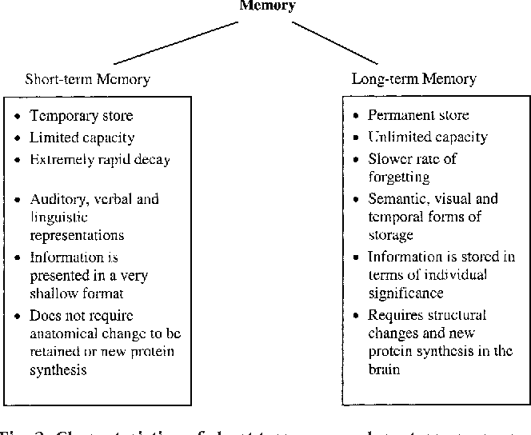

1. **What is Gestalt Theory and Problem Space theory?**

**Answer:**

* Gestalt
  + problem solving both productive and reproductive
  + productive draws on insight and restructuring of problem
  + Attractive but not enough evidence to explain `insight' etc.
  + move away from behaviourism and led towards information processing theories

**Problem space theory**

* + problem space comprises problem states
  + problem solving involves generating states using legal operators
  + heuristics may be employed to select operators  
     e.g. means-ends analysis
  + operates within human information processing system  
     e.g. STM limits etc.
  + largely applied to problem solving in well-defined areas  
     e.g. puzzles rather than knowledge intensive areas

1. **What is Muller-Layer Illusion?**

**Answer:**

The Müller-Lyer illusion is an optical illusion consisting of a stylized arrow. When viewers are asked to place a mark on the figure at the midpoint, they invariably place it more towards the "tail" end.

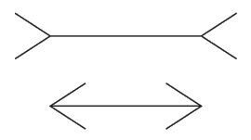

Which line is longer?

The two lines are the same length.

False application of the law of size constancy: top line appears like a concave edge, bottom like a convex edge.

Former therefore seems further away than the latter and is therefore scaled to appear larger.

1. **How human realize the size, color, brightness and dept of a visual image?**

**Size and depth**

-visual angle indicates how much of view object occupies  
 (relates to size and distance from eye)

-visual acuity is ability to perceive detail.

-familiar objects perceived as constant size   
 (in spite of changes in visual angle when far away)

-cues like overlapping help perception of size and depth

**Brightness**

-subjective reaction to levels of light

-affected by luminance of object

-measured by just noticeable difference

-visual acuity increases with luminance as does flicker

**Colour**

-made up of hue, intensity, saturation

-cones sensitive to colour wavelengths

-blue acuity is lowest

-8% males and 1% females colour blind

1. What are the difference between deductive reasoning and abductive reasoning?

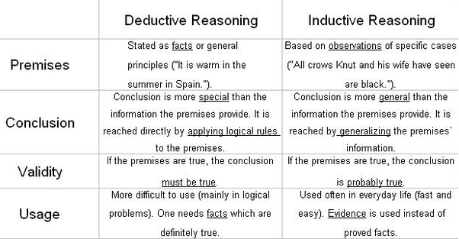

1. **What are the mental models? Why are they important in interface design?**

**Answer:** A mental model is an explanation of someone's thought process about how something works in the real world. It is a representation of the surrounding world, the relationships between its various parts and a person's intuitive perception about his or her own acts and their consequences. Mental models can help shape behaviour and set an approach to solving problems (similar to a personal algorithm) and doing tasks.

A mental model is a kind of internal symbol or representation of external reality, hypothesized to play a major role in cognition, reasoning and decision-making.

**Why:**

1. **Why do we need to study on human psychology in HCI?**

**Answer:**

* Generally, human psychology is called cognitive psychology. One aspect of cognitive psychology affects on the use of computer systems:
  + how humans perceive the world around them,
  + how they store and process information and solve problems, and
  + how they physically manipulate objects.
* So cognitive psychology closely related with designing and building interactive computer systems.

1. What are the different types or error that a human can do? What do you mean by mental model?

Types of error

* slips
  + right intention, but failed to do it right
  + causes: poor physical skill,inattention etc.
  + change to aspect of skilled behaviour can cause slip
* mistakes
  + wrong intention
  + cause: incorrect understanding

Humans create mental models to explain behaviour.

If wrong (different from actual system) errors can occur

**Mental model:** A mental model is an explanation of someone's thought process about how something works in the real world. It is a representation of the surrounding world, the relationships between its various parts and a person's intuitive perception about his or her own acts and their consequences. Mental models can help shape behaviour and set an approach to solving problems (similar to a personal algorithm) and doing tasks.

A mental model is a kind of internal symbol or representation of external reality, hypothesized to play a major role in cognition, reasoning and decision-making.

1. **How do you explain the “Interaction Paradigm”? What are the processes of paradigm shifting?**

**Answer:**

New computing technologies arrive, creating a new perception of the human—computer relationship.

We can trace some of these shifts in the history of interactive technologies.

**Processes:**

* Batch processing
* Timesharing
* Networking
* Graphical display
* Microprocessor
* WWW
* Ubiquitous Computing

1. **Write the name of some pointing devices with their uses.**

**Answer:**

* **The mouse:** Handheld pointing device
  + very common
  + easy to use
  + Two characteristics
  + planar movement
  + buttons

(Usually from 1 to 3 buttons on top, used for making a selection, indicating an option, or to initiate drawing etc.)

**Touchpad:**

* small touch sensitive tablets
* ‘stroke’ to move mouse pointer
* used mainly in laptop computers
* good ‘acceleration’ settings important
  + fast stroke
    - lots of pixels per inch moved
    - initial movement to the target
  + slow stroke
    - less pixels per inch
    - for accurate positioning

**Joystick and keyboard nipple:**

* Joystick
  + indirect  
     pressure of stick = velocity of movement
  + buttons for selection  
     on top or on front like a trigger
  + often used for computer games  
     aircraft controls and 3D navigation
* Keyboard nipple
  + for laptop computers
  + miniature joystick in the middle of the keyboard

**Touch-sensitive screen:**

* Detect the presence of finger or stylus on the screen.
  + works by interrupting matrix of light beams, capacitance changes or ultrasonic reflections
  + *direct* pointing device

**Stylus and light pen:**

* Stylus
  + small pen-like pointer to draw directly on screen
  + may use touch sensitive surface or magnetic detection
  + used in PDA, tablets PCs and drawing tables
* Light Pen
  + now rarely used
  + uses light from screen to detect location
  + BOTH …
  + very direct and obvious to use
  + but can obscure screen

**Digitizing tablet:**

* Mouse like-device with cross hairs
* used on special surface   
   - rather like stylus
* very accurate  
   - used for digitizing maps

**Eye gaze:**

* control interface by eye gaze direction
  + e.g. look at a menu item to select it
* uses laser beam reflected off retina
  + … a very low power laser!
* mainly used for evaluation (ch x)
* potential for hands-free control
* high accuracy requires headset
* cheaper and lower accuracy devices available  
   sit under the screen like a small webcam

**Cursor keys:**

* Four keys (up, down, left, right) on keyboard.
* Very, very cheap, but slow.
* Useful for not much more than basic motion for text-editing tasks.
* No standardised layout, but inverted “T”, most common

**Discrete positioning controls:**

* In phones, TV controls etc.
  + cursor pads or mini-joysticks
  + discrete left-right, up-down
  + mainly for menu selection

1. **What are the elements of WIMP interface?**

**Answer:**

Windows, icons, menus, pointers… or windows, icons, mice, and pull-down menus!

* default style for majority of interactive computer systems, especially PCs and desktop machines

More elements: buttons, toolbars, palettes, dialog boxes

1. **What are the seven stages of Donald Norman’s Model?**

**Answer:**

* Seven stages
  + user establishes the goal
  + formulates intention
  + specifies actions at interface
  + executes action
  + perceives system state
  + interprets system state
  + evaluates system state with respect to goal

1. **What do you mean by ergonomics in context of HCI?**

**Answer:**

* Study of the physical characteristics of interaction
* Also known as human factors – but this can also be used to mean much of HCI!
* Ergonomics good at defining standards and guidelines for constraining the way we design certain aspects of systems
* arrangement of controls and displays

e.g. controls grouped according to function or frequency of use, or sequentially

* surrounding environment

e.g. seating arrangements adaptable to cope with all sizes of user

* health issues

e.g. physical position, environmental conditions (temperature, humidity), lighting, noise,

* use of colour

e.g. use of red for warning, green for okay, awareness of colour-blindness etc.

1. **Discuss different types of interaction style?**

**Answer:**

Common Interaction Style:

* command line interface
* menus
* natural language
* question/answer and query dialogue
* form-fills and spreadsheets
* WIMP
* point and click
* three–dimensional interfaces

1. **What is the difference between error and slip?**

**Answer:**

**Types of error**

* **slips** 
  + right intention, but failed to do it right
  + Causes: poor physical skill, inattention etc.
  + change to aspect of skilled behaviour can cause slip
* **mistakes**
  + wrong intention
  + cause: incorrect understanding

Humans create mental models to explain behaviour.

If wrong (different from actual system) errors can occur

1. **Describe the steps of process design.**

**Answer:**

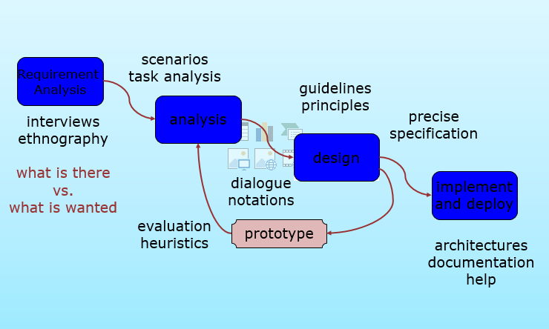

1. **What is prototyping in software design? What are the pitfalls in prototyping?**

**Answer:**

Prototyping in software design:

Prototypes are experimental and incomplete designs which are cheaply and fast developed. Prototyping, which is the process of developing prototypes, is an integral part of iterative user-centered design because it enables designers to try out their ideas with users and to gather feedback [1].

The main purpose of prototyping is to involve the users in testing design ideas and get their feedback in the early stage of development, thus to reduce the time and cost. It provides an efficient and effective way to refine and optimize interfaces through discussion, exploration, testing and iterative revision [2]. Early evaluation can be based on faster and cheaper prototypes before the start of a full-scale implementation. The prototypes can be changed many times until a better understanding of the user interface design has been achieved with the joint efforts of both the designers and the users.

Pitfalls:

1st Pitfall: Diving into the First Good Idea

2nd Pitfall: Falling in Love with Your Prototypes

3rd Pitfall: Wasting Time Explaining and Pitching

4th Pitfall: Prototyping Without a Purpose

5th Pitfall: The Failure Roadblock: Feeling Discouraged by Failed Prototypes

1. **What do you mean by software life cycle?**

**Answer:**

Software engineering is the discipline for understanding the software design process, or life cycle Designing for usability occurs at all stages of the life cycle, not as a single isolated activity

The software life cycle refers to all the phases of a software product throughout its planning, development, and use, all the way through to its eventual obsolescence or retirement. This process has many variable parts, but it can often be segmented into several main pieces. This helps developers and others to understand how a product is created, implemented and used.

1. **What is usability engineering?**

**Answer:**

* Usability engineering is used to determine to what degree a product or prototype will be user-friendly.
* Usability engineering requires a firm knowledge of computer science and psychology and approaches product development based on customer feedback.
* A usability engineer works hand-in-hand with customers, working to develop a better understanding of the functionality and design requirements of a product in order to build more reliable data for it.

1. **Write on gIBIS and design space analysis.**

**Answer:**

**gIBIS :** Graphical Issue-Based Information System

IBIS: Basis for much of design rationale research process-oriented

gIBIS is a graphical version

**Design space analysis:**

A more deliberative approach to design rationale which emphasizes a post hoc structuring of the space of design alternatives that have been considered in a design project. This approach, embodied in the Questions, Options and Criteria (QOC) notation, is characterized as design space analysis.

1. **Define the terms sensor-based and context-aware interaction.**

**Answer:**

* Humans are good at recognizing the “context” of a situation and reacting appropriately
* Automatically sensing physical phenomena (e.g., light, temp, location, identity) becoming easier
* How can we go from sensed physical measures to interactions that behave as if made “aware” of the surroundings?

1. **What is design rationale? List different types of DR. write the benefits of DR.**

**Answer:**

Design rationale is information that explains why a computer system is the way it is, including its

-structural and architectural design

-its functional and behavioural description

**Types of DR:**

**Process-oriented:** preserves order of deliberation and decision-making. Providing a historical record of design decisions.

**Structure-oriented:** Concern with the structure of the space of all design alternatives, which can be reconstructed by post hoc consideration of the design activity.

**Benefits of design rationale**

**Communication throughout life cycle:** Design rationale provides a communication mechanism among the members of a design team so that during later stages of design and/or maintenance it is possible to understand what critical decisions were made, what alternatives were investigated and the reason why one alternative was chosen over the others.

**Reuse of design knowledge across products:** Accumulated knowledge in the form of design rationales for a set of products can be reused to transfer what has worked in one situation to another situation which has similar needs.

**Enforces design discipline:** Forces the designer to deliberate more carefully about design decisions.

**Presents arguments for design trade-offs:** There is usually no single best design alternative. More often, the designer is faced with a set of trade-offs between different alternatives.

**Organizes potentially large design space:** Even if an optimal solution did exist for a given design decision, the space of alternatives is so vast that it is unlikely a designer would discover it.

**Capturing contextual information:** The usability of an interactive system is very dependent on the context of its use. The flashiest graphical interface is of no use if the end-user does not have access to a high-quality graphics display or a pointing device.

**Reuse of design knowledge across products**: Accumulated knowledge in the form of design rationales for a set of products can be reused to transfer what has worked in one situation to another situation which has similar needs.

**Enforces design discipline:** Forces the designer to deliberate more carefully about design decisions.

**Presents arguments for design trade-offs:** There is usually no single best design alternative. More often, the designer is faced with a set of trade-offs between different alternatives.

**Organizes potentially large design space:** Even if an optimal solution did exist for a given design decision, the space of alternatives is so vast that it is unlikely a designer would discover it.

**Capturing contextual information:** The usability of an interactive system is very dependent on the context of its use. The flashiest graphical interface is of no use if the end-user does not have access to a high-quality graphics display or a pointing device.

1. **What is the main element of issue based information system(IBIS)? Draw the hierarchical structure of gIBIS.**

**Answer:**

Main elements:

* **issues**

– Hierarchical structure with one ‘root’ issue

* **positions**

– Potential resolutions of an issue

* **arguments**

– modify the relationship between positions and issues

**Hierarchical structure of gIBIS:**

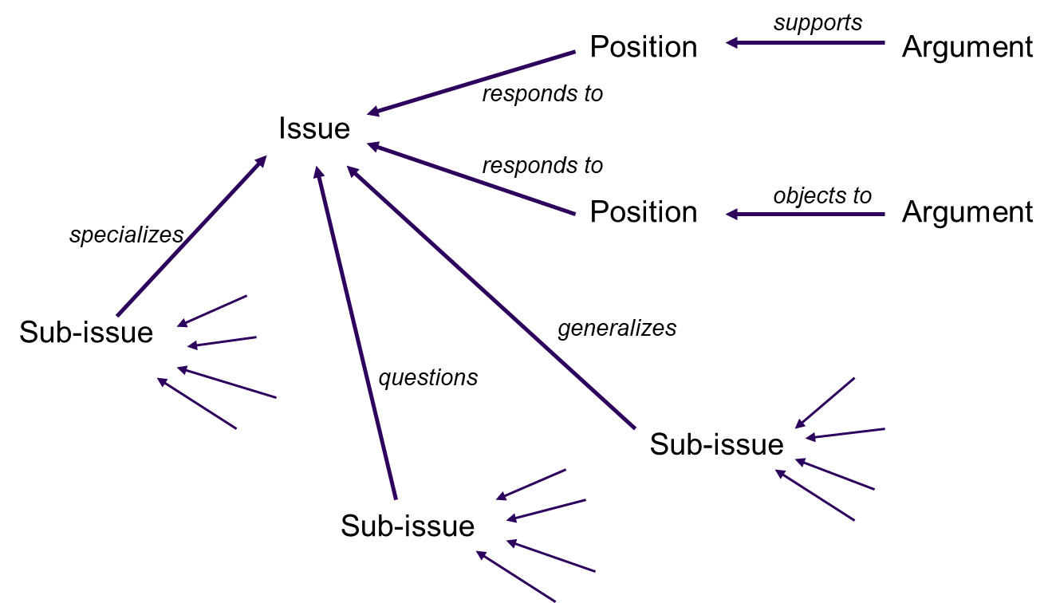

1. **What are differences between interactions and interventions?**

**Answer:**

* **Interactions:** design interactions not just interfaces, not just the immediate interaction
  + e. g. stapler in office – technology changes interaction style
* Manual: write, print, staple, write, print, staple…
* Electric: write, print, write print, …., staple

**Interventions:** designing interventions not just artefacts, not just the system, but also …

* + - documentation, manuals, tutorials
    - what we say and do as well as what we make

1. **What do you mean by software life cycle? Draw the waterfall model for software lifecycle?**

**Answer:**

* Software engineering is the discipline for understanding the software design process, or life cycle
* Designing for usability occurs at all stages of the life cycle, not as a single isolated activity

**Waterfall model for software lifecycle:**

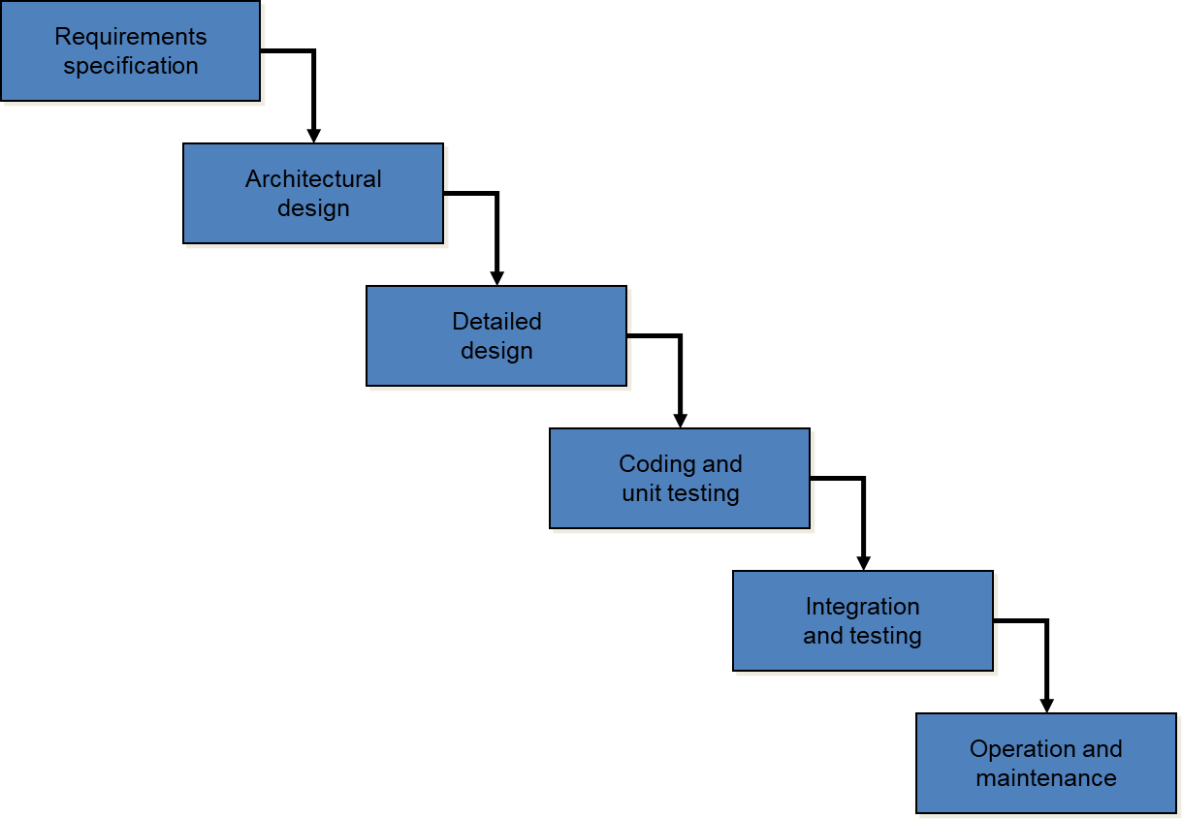

1. **What are the six general attributes that define usability?**

**Answer:**

There are six general attributes define usability: (ISO usability standard 9241)

* + Utility
  + Learn-ability
  + Efficiency
  + Retain-ability
  + Errors
  + Customer satisfaction